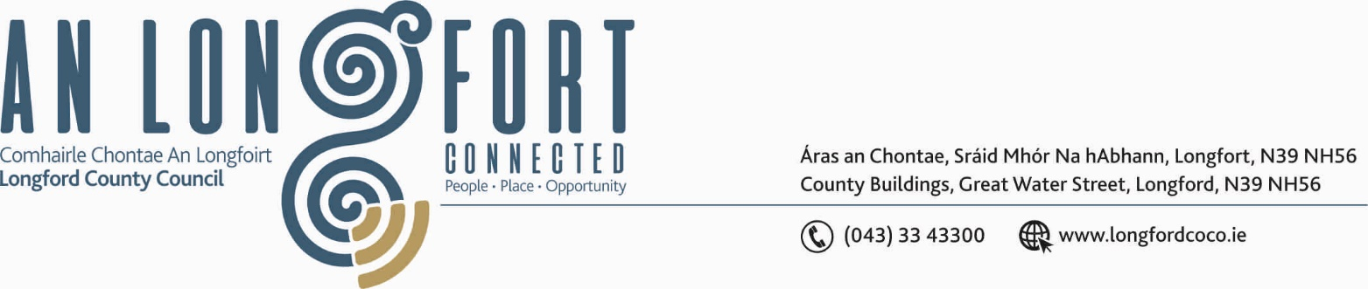

GRANARD MUNICIPAL DISTRICT

Please note meeting will be held in Longford Rugby Club and via Microsoft Teams.

16th June 2021

To: Each Member of Granard Municipal District.

A Chomhairleoir,

You are requested to attend the Annual Meeting of Granard Municipal District to be held in Longford Rugby Club, Demesne, Longford on Tuesday, 22nd June 2021 at 3.30pm to transact business, as set out on the Agenda hereunder.

Mise le meas,

Ann Marie Mc Keon
_______________
Ann Marie Mc Keon,
Meetings Administrator.

C L A R

1. Election of Cathaoirleach.

2. Election of Leas Cathaoirleach.

3. Fix date and time of Granard Municipal District meetings.



